**Soil types and hierarchy (Feature Engineering)**

In case of soil classification, there are 12 main orders of the soil types. 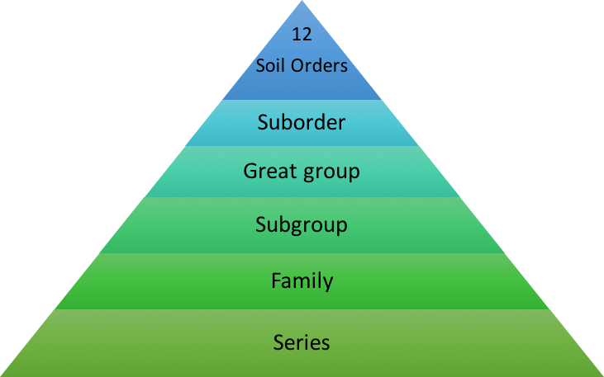

**Order** – Twelve soil orders are recognized. The differences among orders reflect the dominant soil forming processes and the degree of soil formation. Each order is identified by a word ending in 'sol.' An example is Alfisols.

**Suborder**- Each order is divided into suborders primarily on the basis of properties that influence soil formation and/or are important to plant growth.

**Great Group** – Each suborder is divided into great groups on the basis of similarities in horizons present, soil moisture or temperature regimes, or other significant soil properties.

**Subgroup** – Each great group has a ‘typic’ (typical) subgroup which is basically defined by the Great Group. Other Subgroups are transitions to other orders, suborders, or great groups due to properties that distinguish it from the great group.

**Family** – Families are established within a subgroup on the basis of physical and chemical properties along with other characteristics that affect management.

**Series** – The series consists of soils within a family that have horizons similar in color, texture, structure, reaction, consistence, mineral and chemical composition, and arrangement in the profile.

The main 12 Soil orders are **Entisols, Inceptisols, Andisols, Mollisols, Alfisols, Spodosols, Ultisols, Oxisols, Gelisols, Histosols, Aridisols, and Vertisols**.

Each order is based on one or two dominants physical, chemical, or biological properties that differentiate it clearly from the other orders. Perhaps the easiest way to understand why certain properties were chosen over others is to consider how the soil (i.e., land) will be used.

As we have 40 different soil types in the dataset, it is really hard to manage this many features in the model and we can reduce the by classifying them into main parent classes.

With the help of various survey sites like soilweb.com, we can easily find out the parent type of the given soil family. We can easily find out the order and sub group with the help of survey information.

Example:

Soil_Type1 is from the Cathedral family.

search the family in

https://soilmap2-1.lawr.ucdavis.edu/sde/?series=mccall#shared-subgroup

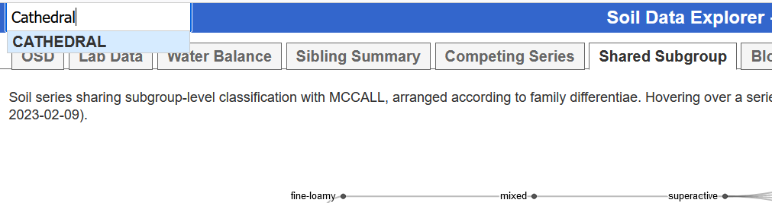

Go to the Shared subgroup option for the hierarchical diagram

In this tab we will get the main parent sub group of the soil family.

Go to soil website and search for sub-group. We will get to see the main order of the soil.

Next, we will check if there is any strong relationship between soil order types and forest cover types.

References:

https://soilmap2-1.lawr.ucdavis.edu/sde/?series=mccall#shared-subgroup

https://digitalatlas.cose.isu.edu/geo/soils/soiltxt/soiltax.htm